e-commerce sales analysis

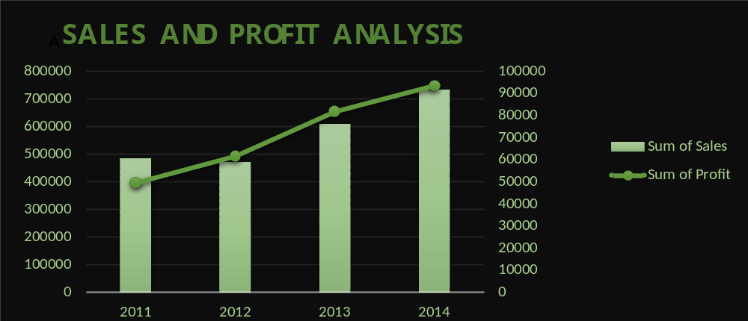

1) By the help of this graph we can analyse that how our profit increses with respect to our sales on yearly basis.
2) Here we can see that our sales which is 5 lakh in 2011 has increased to 7 lakh in 2014.
3) Where as we can also see that our profit which is 50 thousand in year 2011 has now increased to 90 thousand in year 2014.
4) Here we can analyse that our profit grows by 80% in 3 years
where as our sales increses 40% in same timeline.

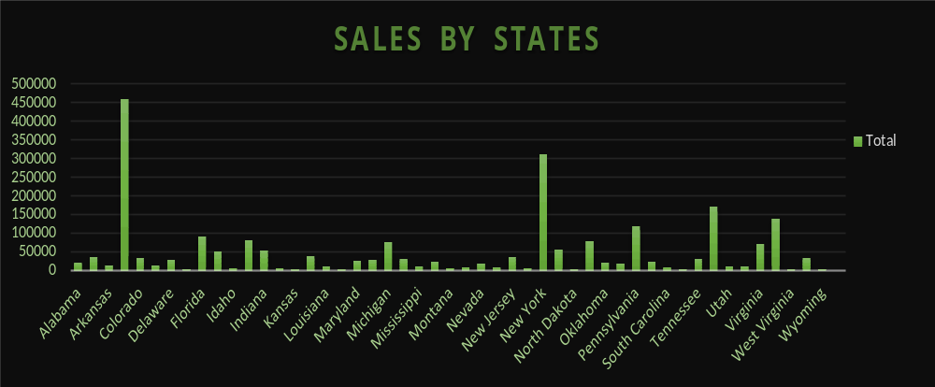
1) By the help of this graph we can analyse that which state has maximum sales.
2) Here we can see that Arkansas has max sales figure followed by NewYork and Utah respectively.
3) Where as we can also see that Arkansas account for 4.5 lakh sales
where as NewYork account for 3.5 lakh sales and Utah accounts
for 1.75 lakh sales.

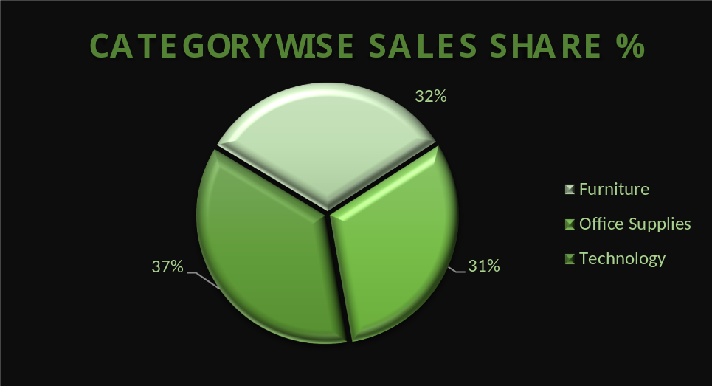
1) By the help of this graph we can analyse Categorywise sales share percentage.
2) Here we can see that maximum sales comes from category called Technology which accounts for 37% of total sales, followed by category called furnitures which accounts for 32% of total sales and then comes category called Office Supplies which accounts for 31% of total sales.

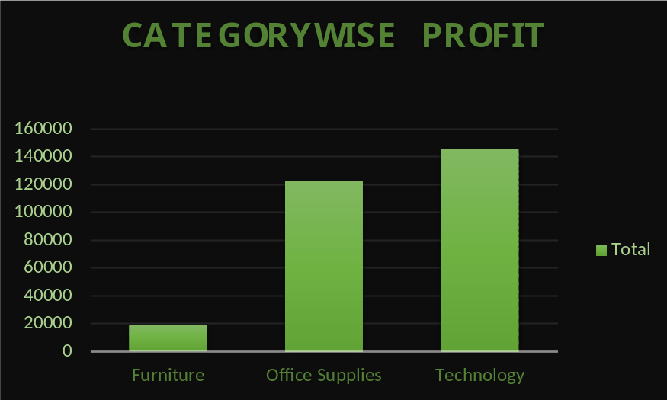

1) By the help of this graph we can analyse the categorywise profit.
2) Here we can analyse that the maximum profit comes from category called Technology which is 1 lakh and 40 thousand followed by Office Supplies which is 1 lakh 20 thousand and last was Furniture which gave us the profit of 20 thousand.

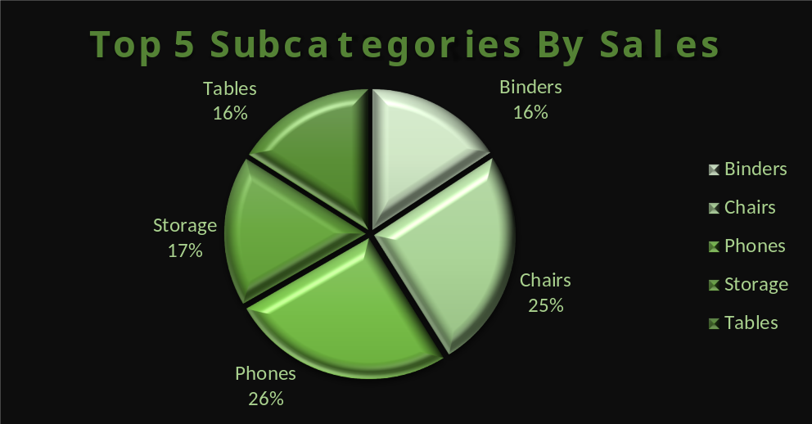

1) By th help of this graph we can analyse the Top 5 Subcategories by sales .
2) Here we can analyse that Subcategory which tops the sales is Phones which accounts for 26% of all sales.
Second Top Subcategory is Chairs which accounts for 25% of total sales.
Third Top Subcategory is Storage which accounts for 17% of total sales.
Fouth Top Subcategory is Tables which accounts for 16% of total sales.
Fith Top Subcategory is Binders which accounts for 16% of total sales.

